**PROJECT TOPIC:** Smart Wearable AI IOT for Appliance Control

**Group No.:**

**Project Group Members:**

1. Akash Nigam(191500074)
2. Akarsh Agarwal(191500069)
3. Anindya Trivedi(191500116)
4. Biprajit Debnath (191500221)
5. Devansh Jain (191500254)

**Project Supervisor:** Dr. Ram Manohar Nisarg (Master Trainer CSED)

**About the Project:**

The present invention provides a Low-Cost Wearable Health Monitoring Device comprising plurality of sensors to measure the vital information of an old or disabled person; a module consisting pre-programmed controller which store the normal vital parameter to be monitored, during old age and based on comparison generating an alert signal which is transmitted through a transmitter to ambulance, doctor and family member; a communication device adapted for continuous establishment of network with the data storing means where the vital information gets stored; and output means from where the family member and doctor can access the information. The system has an advantage of creating a proper database of the old/disabled person and is cost-efficient and reliable.

**Motivation:**

In the past few years, we have realised that the Elderly or a disabled face a lot of problems. The motivation behind this project is to provide an elderly or a disabled person a complete all-in-one package to monitor the health of the person and provide insights about health to both guardian and the doctor.

Adding to its features, the kit will come with a dedicated application and a fall alert system.

**Project Planning:** Deciding problem statement, Drawing solution statement, hardware and software selection, Implementation, Data Collection and drawing constraints , Hardware Testing, Software Testing, Live Testing.

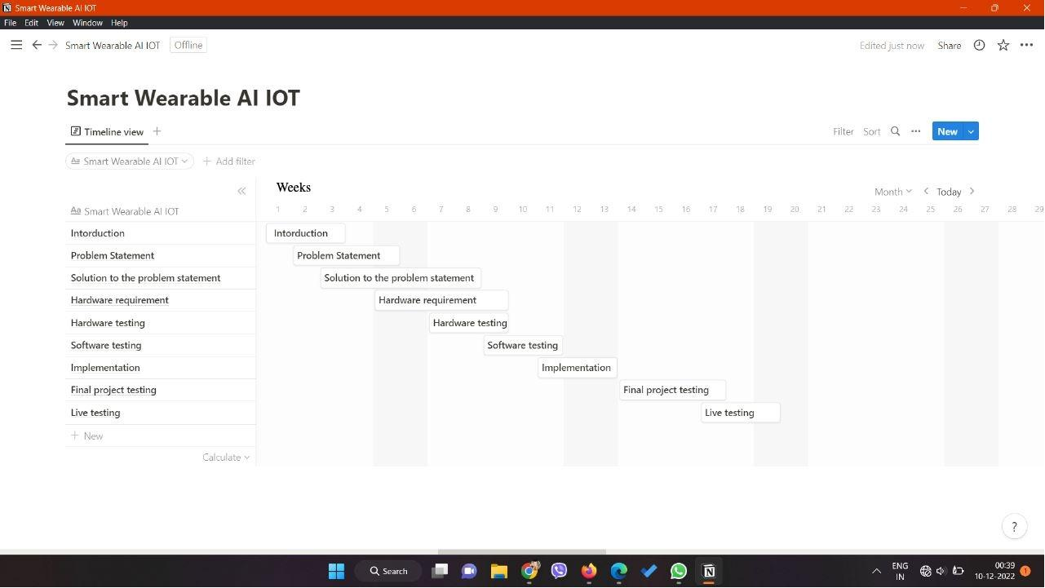

**Tools required:**

* **Hardware Requirements:**

**Heart Rate Sensor**

**GSR Sensor**

**MPU-6050**

**Analog Temperature Sensor**

**RFID Reader/Writer**

**Capacitive Touch Sensor**

**Node MCU ESP-8266**

* **Software Requirements:**

**Arduino IDE**

**ThingWorx**

**MIT App Inventor**

**Signature of Project Supervisor: __________________**